**Select Multiple Items**

**Item:**

**Sales order:**

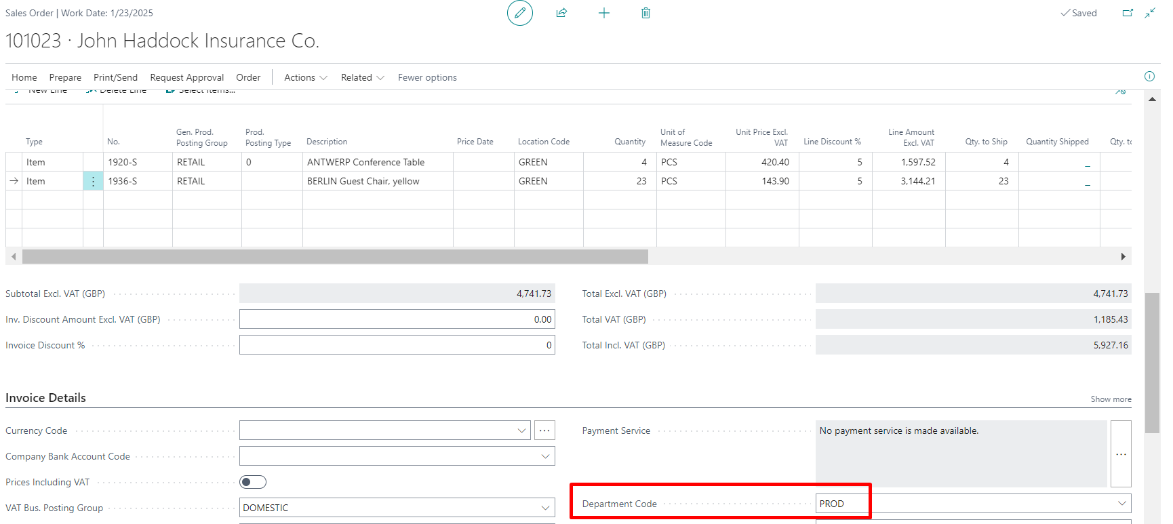

**After Click Select Item:**

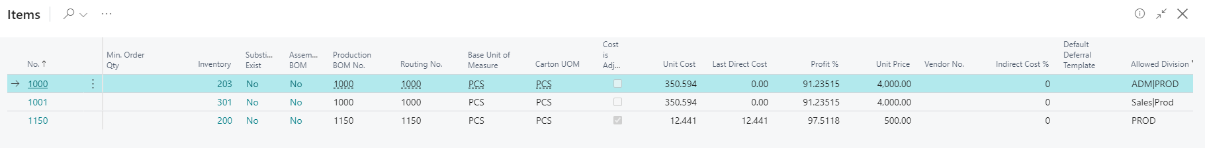

**Item List:**

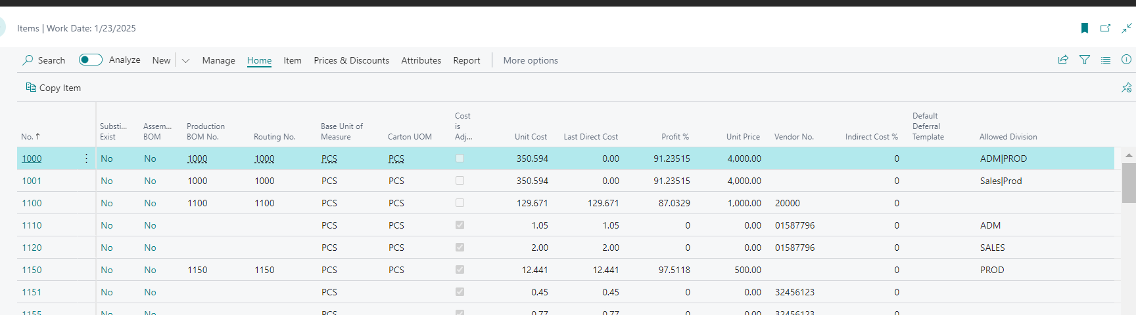

**Same button applied in Below Sales Document:**

**1 Sales Order 2 Sales Quote 3 Sales Invoice**

**4 Blanket Sales Order 5 Sales Credit Memo 6 Return Sales Order**

**Case 2:**

**Purchase Order :**

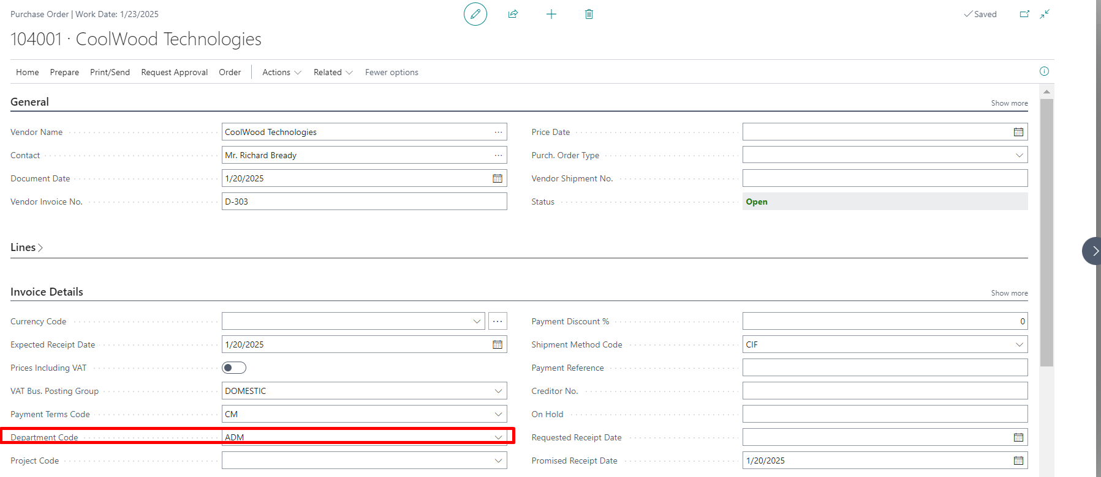

**After Click Select Item:**

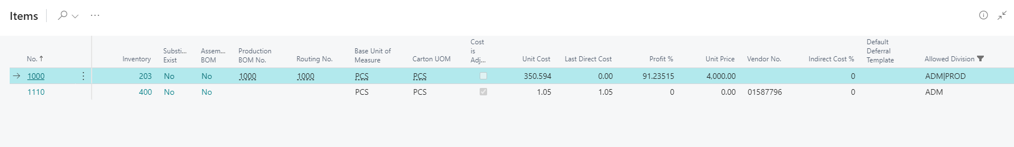

**Same button applied in Below Purchase Document:**

**1 Purchase Order 2 Purchase Quote 3 Purchase Invoice**

**4 Blanket Purchase Order 5 Purchase Credit Memo 6 Return Purchase Order**